Time Series Forecasting for Air Quality Trends

Nour Eddin Abdulsalam Alchmri∗, Yonatan Moges Yigezu†‡, Isam Al Jawarneh§
∗Department of Computer Science, University of Sharjah, Sharjah, UAE
Email: u24200614@sharjah.ac.ae
‡Department of Computer Science, University of Sharjah, Sharjah, UAE
Email: u24200574@sharjah.ac.ae
§Department of Computer Science, University of Sharjah, Sharjah, UAE
Email: ijawarneh@sharjah.ac.ae

Abstract— Air pollution, especially the concentration levels of fine particulate matter PM2.5, potentially poses serious hazards to urban ecosystems and public health, therefore precise forecasting models are required for proactive mitigation. Using geohash-encoded air quality data, this paper examines the use of ARIMA (AutoRegressive Integrated Moving Average) models to forecast short-term PM2.5 trends in two major American cities: New York and Boston. We trained city-level and geohash-level ARIMA models by using cleaned datasets for air quality that were split for training and testing, and performance was assessed through visualization and metrics such as RMSE and MAPE. The findings revealed that geohash-level models performed much better than city-wide forecasts, but also pointed up ARIMA’s inherent limitations such as its inability to handle exogenous variables or capture nonlinear patterns, necessitating the use of more powerful alternatives like SARIMAX or LSTM. The possibility of policy-driven interventions was highlighted by a simulated green policy scenario that showed a projected 30% reduction in PM2.5 levels. This study promotes hybrid modeling techniques to handle real-world complexities while contributing to the conversation on geospatial-aware and scalable air quality forecasting.
Keywords—ARIMA, PM2.5, forecasts, geohash, time series, air quality, green policies, RMSE, MAPE,

Introduction
Air pollution has been a prominent global problem as it significantly impacts climate, global temperature levels, public health and urban ecosystems. In large, densely populated cities like Boston, Chicago and New York City, fine particulate matter found airborne (especially PM2.5) has been proven to cause respiratory illnesses, cardiovascular conditions and premature mortality. Therefore, real-time monitoring and forecasting of air quality are crucial to provide valuable insights for traffic regulation strategies, public health advisories and emission control measures.
Creating models that learn from historical environmental data to forecast pollution levels in the future is now a possibility thanks to recent advancements in the fields of data science and time series analysis. These models can be used to design proactive actions, evaluate the impact of urban policies, and predict pollution surges. However, because of the dynamic and nonlinear interactions between pollutants, traffic patterns, weather, and geographic features, predicting trends in air quality is still a challenging issue.
This research focuses primarily on the development and performance assessment of time-series forecasting models for predicting PM2.5 concentration levels across three significant American cities: Chicago, Boston and New York City. We will investigate statistical methods like ARIMA models to produce precise short-term forecasts using cleaned air quality datasets containing metrics such as temperature, humidity, carbon monoxide concentration, nitrogen dioxide concentration and PM2.5 levels. In order to examine and analyze localized pollution patterns, geohash-based spatial aggregation has been utilized.
Our research includes preprocessing and feature engineering for air quality datasets, development and evaluation of forecasting models, simulation of various scenarios like peak traffic hours and policy recommendations to mitigate air pollution in the future.

Related Literature
Forecasting air quality has attracted a lot of interest recently because of its potential for massively improving public health and environmental policies. To forecast air pollution levels, especially fine particulate matter PM2.5 levels, various approaches have been explored ranging from conventional statistical models to sophisticated machine learning algorithms.

Time Series Forecasting Models
Authors in [1] studied short-term, high-granularity PM2.5 forecasting by using and comparing ten distinct models, including: ARIMA, SARIMA, exponential smoothing variants, decision trees, artificial neural networks (ANN), k-nearest neighbors (kNN), long short-term memory (LSTM) networks and Markov Chain First Order (MCFO). Their study concluded that kNN models outperformed other models in longer-term forecasts while LSTM showed great performance for short-term forecasts. Interestingly, ARIMA demonstrated a disappointing performance for extended forecasts.
On the other hand, authors in [2] concentrated specifically on long-term pollution in the eastern Indian city of Kolkata through the comparison of deep learning methods like auto-encoder and convolutional LSTM networks, with regular statistical models such as SARIMA and Holt-Winters. Their study revealed that deep learning approaches were outperformed by statistical models in long-term forecasts, demonstrating the relevance of traditional approaches for certain situations.
The Prophet model, developed by Meta, is another tool commonly used for producing high quality time-series forecasts. In a study conducted in the Chinese province of Jiangsu, Prophet successfully identified seasonal and trend components in PM2.5 data, providing precise forecasts while needing minimal data preprocessing [3].

Geospatial Data Processing in Air Quality Forecasting
Improving the geographical precision and real-time applicability of air quality forecasts has been made possible by the incorporation of geospatial data processing tools like geohashes.
Recently, the authors in [4] presented ApproxGeoMap, an effective system for creating approximation geo-maps from quickly arriving georeferenced data streams. ApproxGeoMap improves both processing speed and accuracy by using stratified spatial sampling based on Earth Mover’s Distance for error estimates. This ensures quick and reliable geospatial visualizations, which are crucial for smart city applications.
In another approach, authors in [5] introduced ApproxGeoAgg which is a system that utilizes the Douglas-Peucker algorithm to simplify polygon boundaries and geohash encoding for effective filtering in order to optimize geospatial aggregation queries like Top-N, mean and count. While preserving statistically acceptable results, this method decreases computational costs by obtaining quicker query times with negligible accuracy loss. The system balances accuracy and performance in large-scale geospatial analytics and shows scalability in distributed environments, offering a practical solution for smart city applications.
Similarly, the paper [6] presents ApproxGeoViz, which is a system that efficiently approximates chloropleth maps from big geospatial data streams. Measured via EMD, the system reduces computational overhead while retaining accuracy by utilizing a geohash-based spatial sampling. This system tweaks sampling rates dynamically to balance QoS limitations and visualization fidelity. The system's modular architecture, which consists of a renderer, a QoS controller, and geohash-based tessellation, works especially well for smart city applications like traffic monitoring.
Additionally, researchers in [7] provided a novel technique for polygon simplification called GeoRap, which is an online geospatial approximation system that efficiently analyzes georeferenced data. By lowering processing overhead without appreciably sacrificing accuracy, this method enables real-time geographical analysis, facilitating dynamic environmental monitoring and decision-making processes.

Methodology
In this section, we discuss the methodology that was employed for this research, including the procedures followed for data preprocessing, exploratory data analysis, forecasting model creation and training and scenario simulation. We will also discuss the different algorithms, tools, formulas used as well as the architecture of the system.

Data Preprocessing
We performed basic data preprocessing on the air quality datasets for the cities of Boston and New York. Any fragmented datasets were combined into a single file for both cities in order to simplify processing, and performed basic cleaning of the data by sorting the time columns and converting them from Unix timestamp to a more readable datetime format. Finally, we added geohashes of precision level 6 as a column for each dataset via encoding from longitude and latitude then saved the cleaned datasets in csv format to be used for the next step.

Exploratory Data Analysis (EDA) and Data Splitting
Firstly, basic information about the cleaned data was displayed and graphs of missing values and time series graphs of PM2.5 values based on the cleaned datasets were plotted. Time series PM2.5 graphs for the top 3 geohashes were also drawn.
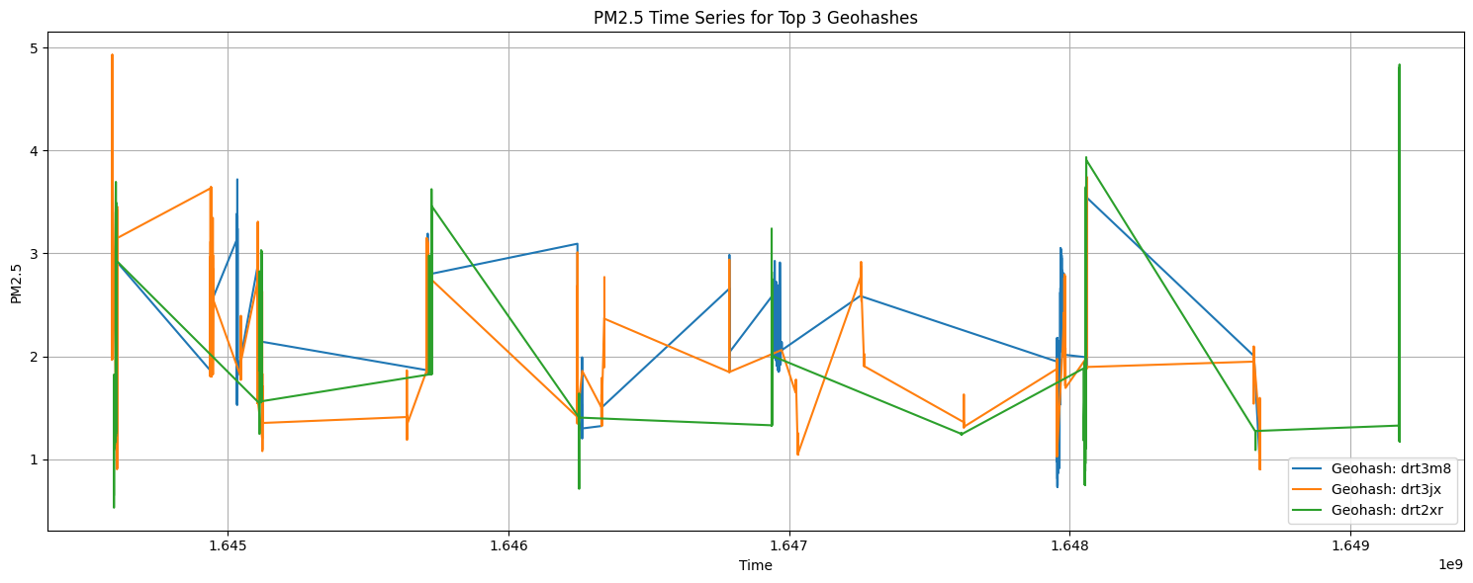
Secondly, the datasets for both cities were split into training and testing data to be used later for training the ARIMA models and verifying their outputs. 80% of the data is allocated for training while 20% is reserved for testing purposes.
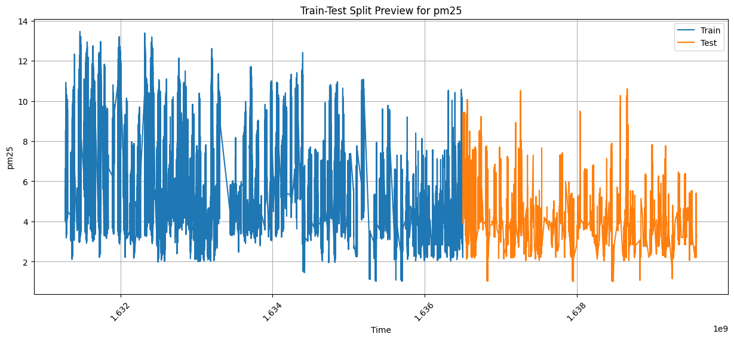
Figure 2 below visualizes how the data for training and testing were split for the cleaned New York dataset.
For New York, 412733 rows were allocated for training and 103184 for testing, while for Boston the training size is 98214 and test size is 24554.
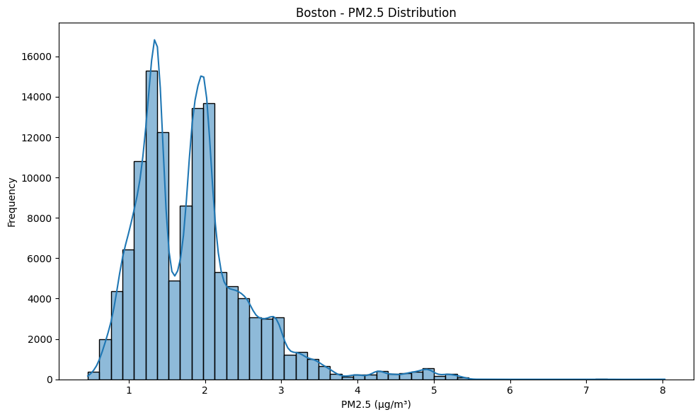
The figure 3 above shows the distribution among different values of PM2.5 levels in the city of Boston. The histogram peaks at around 1.3-1.4 µg/m³ and 1.9-2.1 µg/m³.

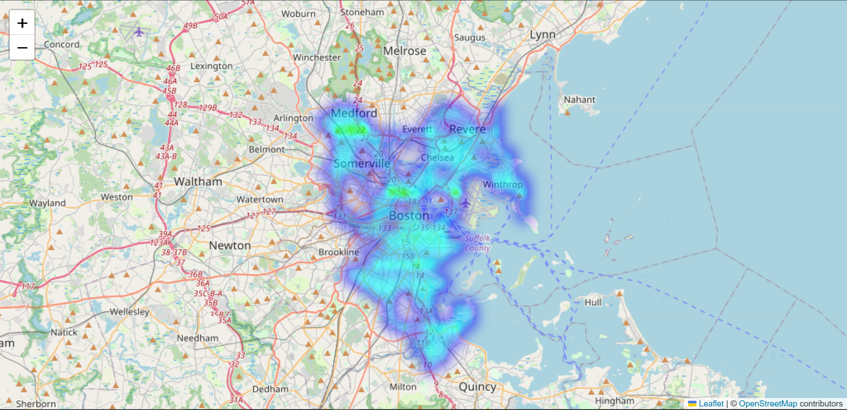
The figure 4 above shows a heatmap demonstrating the spatial distribution of PM2.5 levels across Boston, with more densely populated areas showing higher levels of air pollution.
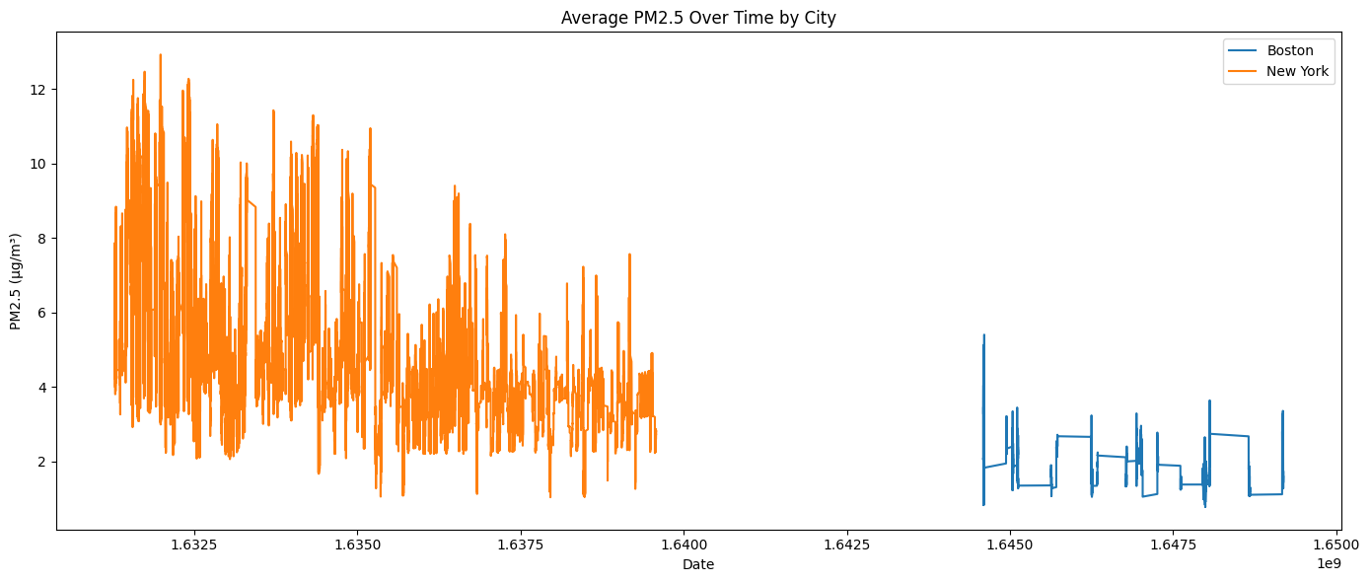
The figure 5 above shows the average levels of PM2.5 over time for both cities

Modelling Forecasts
For modelling time-series forecasts of PM2.5 levels, ARIMA models were created and trained with the previously split datasets.
AutoRegressive Integrated Moving Average, otherwise known as ARIMA, is a famous statistical tool mainly used for time series forecasts. First proposed by Box and Jenkins in [8] as a method to forecast non-stationary time-series, it combines three main parts to recognize patterns in temporal data:
- AR (AutoRegressive): This models the relationship between an observation and past (lag) values
- I (Integrated): Utilizes differencing to make the time series stationary through the removal of trends
- MA (Moving Average): Models the relationship between observations and errors from previous forecasts
The general ARIMA model is denoted as ARIMA(p, d, q), where the p, d and q parameters are:
- p: The lag order, used in the AutoRegression component (order of autoregression)
- d: The number of times the data is differenced, used in the Integrated part (order of differencing)
- q: The window size of residuals, used in the Moving Average component (order of the moving average)
The general formula of ARIMA(p,d,q) is represented as:
$Y_{t}^{'}=c+ ϕ_{1}Y_{t-1}^{'} + ϕ_{2}Y_{t-2}^{'}+…+ ϕ_{p}Y_{t-p}^{'}+ ϵ_{t}+ θ_{1}ϵ_{t-1}+ θ_{2}ϵ_{t-2}+…+ θ_{q}ϵ_{t-q}$ (1)
Where $Y_{t}^{'}$ is the stationary and differenced time series at t, c is a mean of the series (constant), $ϕ$ are autoregressive parameters representing reliance on previous values, $ϵ_{t}$ is the white noise error and $θ$ values represent moving average parameters depending on past prediction errors.
The figure 6 below shows the system architecture of the ARIMA model:
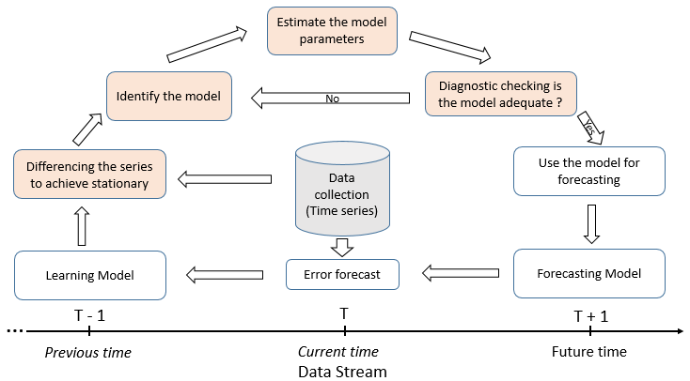
Figure 6: ARIMA model system architecture [9]
ARIMA models are usually used in the fields of economics, healthcare and climate science. Researchers in [1] and [2] used variants of ARIMA models with varying levels of success.
ARIMA models provide excellent performance with univariate (single variable, PM2.5 in this case) time series, hence it was chosen for this task of forecasting short-term PM2.5 values.
For modelling the forecasts, city-level and geohash-level ARIMA models were created and trained with the training data from the previous step then verified with the data reserved for testing purposes.
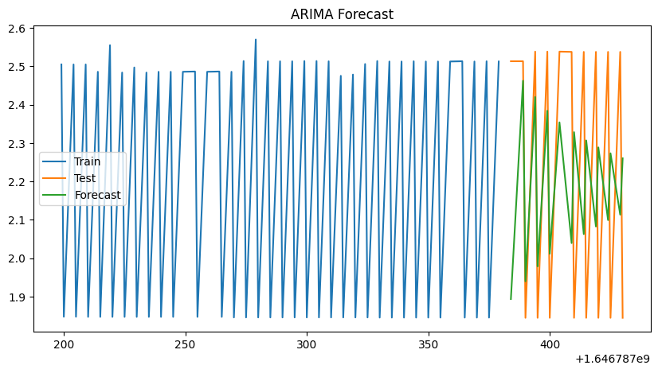
Figure 7 above shows the forecast for PM2.5 levels in an area in Boston, with the training data shown in blue, testing data in orange and forecast in green.
To help evaluate the performance of the ARIMA model’s prediction against the original test data, two statistical metrics were used: Root Mean Square Error (RMSE) and Mean Absolute Percentage Error (MAPE).

Root Mean Square Error: A statistical metric that calculates the average magnitude of forecasting errors by heavily penalizing larger errors due to squaring. The formula is as follows:
$RMSE= \sqrt{\frac{1}{n}\sum_{i=1}^{n}{\left(y_{i}- y_{i}^{^}\right)}}$ (2)
Where $y_{i}$ is the actual value, $y_{i}^{^}$ is the predicted value and n is the number of observations.

Mean Absolute Percentage Error: Calculates the average percentage error in relation to actual values. It is used when relative error is more important than absolute error, therefore it is easier to understand by non-technical stakeholders. The formula is as follows:

$MAPE= \frac{100\%}{N}\sum_{i=1}^{n}{\left|\frac{y_{i}- y_{i}^{^}}{y_{i}}\right|}$ (3)

Scenario Simulation
After training ARIMA models for all geohashes in both cities, the next step is to simulate a scenario – like a real-life policy or event – that would affect the PM2.5 values using the recently trained models.
The fictional scenario chosen for simulation is a strong green governmental policy of:
- Phasing out fossil fuel cars
- Electric public transit (buses and trains)
- Incentives for buying electric cars in the form of tax exemptions
- Renewable energy mandates
- Smart city planning to reduce traffic
- Public awareness and clean tech R&D funding
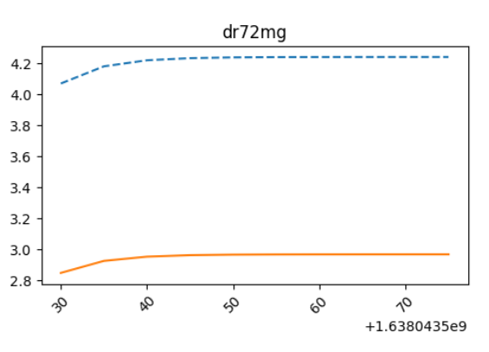
Which are assumed to reduce PM2.5 levels by 30%.
Figure 8 above demonstrates the consequence of reducing testing PM2.5 data by 30% to simulate a green policy for a specific geohash in Boston. The dashed blue line represents the baseline (original) forecast while the solid orange line represents the scenario forecasts. This scenario was applied to all geohashes of both cities.

Results and Discussion
The creation and training of ARIMA models and the scenario simulation showed varying levels of success.
The ARIMA models’ Geohash-level PM2.5 forecasts showed far better accuracy than city-wide forecasts as evidenced by lower RMSE and MAPE values. Additionally, our ARIMA models did not yield insightful forecasts on sparsely populated geohash regions compared to densely populated areas.
The simulations demonstrated great effectiveness of implementing strong green policies to help mitigate air pollution as shown by the simulation forecasts being much lower than the baseline forecasts.
However, ARIMA showed an overall disappointing performance in this application due to the following:
- It could only capture linear patterns in data and fails to model nonlinear trends such as sudden spikes in PM2.5 levels due to wildfires and other factors.
- It assumes the time series is stationary (as in constant mean and variance over time), therefore it cannot handle seasonal data.
- ARIMA by itself cannot properly handle missing data or gaps, causing bias. Thus, manual interpolation of data is crucial before using a regular ARIMA model.
- It is mainly designed for short-term forecasts only (days or weeks), as long-term forecasts could accumulate errors due to recursive prediction.
- Standard ARIMA can only handle univariate (single variable) data, causing it to be unable to simulate scenarios influenced by other factors like temperature or humidity.
- ARIMA assumes the errors to be normally distributed, as a result it cannot handle outliers as they can distort the forecasts.

Conclusion and Future Works
To summarize this research, we performed basic cleaning and organizing of the datasets for easier processing then displayed insights about the cleaned data using exploratory data analysis through plots and heatmaps, afterwards we split the data into training and testing sets, and finally we trained ARIMA models for forecasting PM2.5 levels and simulated a green policy scenario to compare between baseline forecasts and scenario forecasts.
Scenario simulation graphs demonstrate how well-planned green policies can help improving air quality and decrease PM2.5 levels as evidenced by Figure 8.
The trained models show an overall disappointing level of precision due to the inherent weaknesses of the standard ARIMA model such as the inability to handle outliers and multivariate data and lack of long-term forecasting capabilities.
To improve forecast performance in future applications, better statistical models such as SARIMAX (Seasonal Autoregressive Integrated Moving Average and exogenous variables) could be used to produce more accurate results and simulate more complex scenarios as it can handle multivariate data and seasonal trends.
Furthermore, ML-based forecasting tools such as LSTM and Prophet could also be explored in future research to compare between statistical models and machine learning models in terms of forecasting performance.

References

- R. Das, A. I. Middya, and S. Roy, “High granular and short term time series forecasting of pm2.5 air pollutant - A comparative review,” Artificial Intelligence Review, vol. 55, no. 2, pp. 1253–1287, Mar. 2021. doi:10.1007/s10462-021-09991-1
- P. Nath, P. Saha, A. I. Middya, and S. Roy, “Long-term time-series pollution forecast using statistical and deep learning methods,” Neural Computing and Applications, vol. 33, no. 19, pp. 12551–12570, Apr. 2021. doi:10.1007/s00521-021-05901-2
- A. Hasnain et al., “Time series analysis and forecasting of air pollutants based on Prophet forecasting model in Jiangsu Province, China,”
Frontiers in Environmental Science, vol. 10, Jul. 2022. doi:10.3389/fenvs.2022.945628
- R. A. Alshamsi, I. M. Al Jawarneh, L. Foschini, and A. Corradi, “ApproxGeoMap: An efficient system for generating approximate geo-maps from big geospatial data with quality of service guarantees,” Computers, vol. 14, no. 2, p. 35, Jan. 2025. doi:10.3390/computers14020035
- I. M. Jawarneh, R. Montanari, and A. Corradi, “Cost-effective approximate aggregation queries on geospatial Big Data,” 2023 IEEE Globecom Workshops (GC Wkshps), pp. 1313–1318, Dec. 2023. doi:10.1109/gcwkshps58843.2023.10465045
- I. M. Jawarneh, L. Foschini, and A. Corradi, “Efficient generation of approximate region-based geo-maps from Big Geotagged Data,” 2023 IEEE 28th International Workshop on Computer Aided Modeling and Design of Communication Links and Networks (CAMAD), Nov. 2023. doi:10.1109/camad59638.2023.10478398
- I. M. Al Jawarneh, L. Foschini, and P. Bellavista, “Polygon simplification for the efficient approximate analytics of georeferenced Big Data,” Sensors, vol. 23, no. 19, Sep. 2023. doi:10.3390/s23198178
- G. E. P. Box and G. M. Jenkins, Time Series Analysis: Forecasting and Control. San Francisco, CA, USA: Holden-Day, 1970.
- A. Elmouatamid et al., “A control strategy based on power forecasting for Micro-Grid Systems,” 2019 IEEE International Smart Cities Conference (ISC2), pp. 735–740, Oct. 2019. doi:10.1109/isc246665.2019.9071722

